**Introduction to HTML**

**What is HTML?**

* **HTML = HyperText Markup Language**
* **Standard language to structure web pages**
* **Defines elements like headings, paragraphs, links, images**
* **Every website you visit uses HTML at the base**
* 📍 Example: Think of a **newspaper** → headlines, images, paragraphs → HTML organizes web content similarly

### **Slide 4:** Structure of an HTML Document

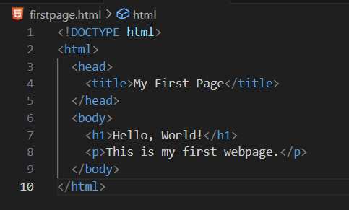

<!DOCTYPE html> → Defines HTML5

<html> → Root tag

<head> → Title, metadata, CSS/JS links

<body> → Visible content

**Basic HTML Tags**

* **Headings:** <h1> to <h6>
* **Paragraphs:** <p>
* **Line break:** <br>
* **Horizontal rule:** <hr>
* **Formatting:** <b>, <i>, <u>, <strong>, <em>

**Lists in HTML**

**Ordered List (Numbers):**

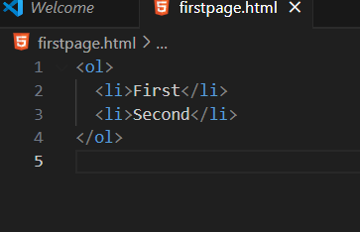

**Unordered List (Bullets):**

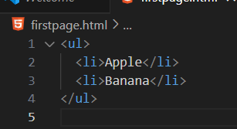

**Links & Images**

**Hyperlink Example:**

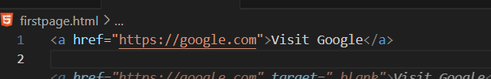

**Image Example:**

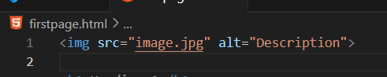

**HTML Tables**

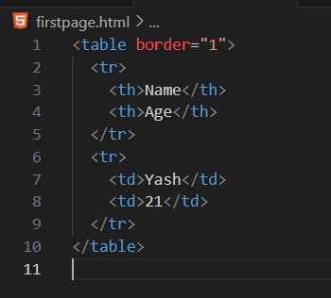

**HTML Forms**

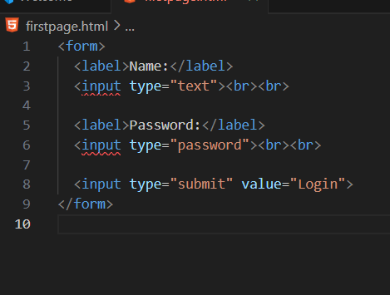

**Activity – Personal Profile Page**

👉 Create a webpage with:

* Your **name** in <h1>
* A **paragraph** about yourself
* An **image** (online link or photo)
* A **list** of hobbies
* A **table** of education details
* A **form** for feedback